Joshua’s House for Golden Retriever Rescue & Sanctuary, Inc

Bandana Order

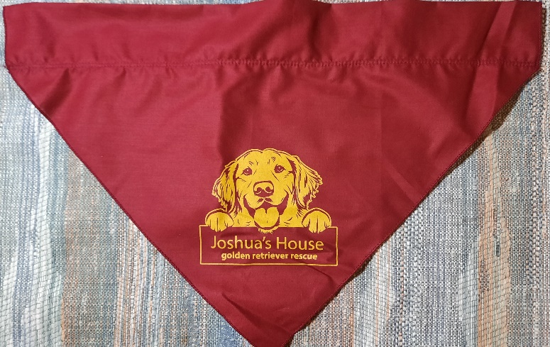Bandanas are $10 which includes shipping.



**To order Bandanas, please provide the following**

Name - ______________________________

Address - ______________________________

City - ______________________________

State - _________________

Zip - _________________

Email - ______________________________

Phone - _________________

# ordered - ______ $10 each

Check made payable to JOSHUA’S HOUSE - $10 each

Mail form & check to: Joshua’s House

595 S WEST BEND PT

LECANTO FL 34461-9649