Joshua’s House for Golden Retriever Rescue & Sanctuary, Inc

T-Shirt Order

T-Shirts are $25 which includes shipping.

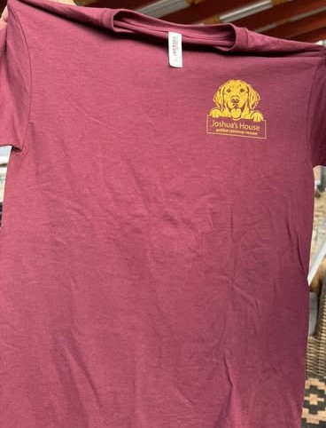

**To order T-Shirts, please provide the following**

Name - ______________________________

Address - ______________________________

City - ______________________________

State - _________________

Zip - _________________

Email - _________________

Phone - _________________

# Shirts - ______ Size - ________ (S,M,L,XL,2X) $25 each

Check made payable to JOSHUA’S HOUSE - $25 each

Mail form & check to: Joshua’s House

595 S WEST BEND PT

LECANTO FL 34461-9649